**Transforming Cyber-Physical Systems: Machine Learning for Secure and Efficient Solutions**

**Harsh Fulambarkar1, Santoshi Kelzarkar 2, Harshita Mirase3, Bhagyashree Kumbhare4, Prof. Ms. Yamini B. Laxane 5**

Students, MCA, Smt. Radhikatai Pandav College of Engineering, Nagpur, India1,2,3

HOD, MCA, Smt. Radhikatai Pandav College of Engineering, Nagpur, India4,5

**Abstract:** This paper explores the pivotal role of Machine Learning in transforming Cyber-Physical Systems, a field where the integration of physical processes with computational models offers substantial advancements in various sectors. ML has proven instrumental in enhancing predictive capabilities, optimizing system operations, and strengthening data security within CPS. As industries such as healthcare, smart infrastructure, and transportation continue to adopt CPS technologies, ML has become a critical enabler for real-time data analysis, anomaly detection, and automated decision-making, fostering more efficient and intelligent systems. The growing reliance on CPS for mission-critical applications necessitates robust solutions for managing vast amounts of data and ensuring system reliability. However, despite these advancements, significant challenges persist, including concerns around privacy, adversarial attacks, and scalability. These issues present barriers to the widespread deployment and trust in CPS technologies. This paper provides a comprehensive examination of ML's transformative impact on CPS, emphasizing its role in overcoming operational challenges and enhancing system resilience. Additionally, it discusses the importance of developing more secure, scalable, and transparent ML models that can address the evolving needs of CPS. Future research will focus on refining these techniques, improving model interpretability, and implementing more adaptive solutions to meet the demands of an increasingly interconnected world.

**Keywords:** Machine Learning, Cyber-Physical Systems, Predictive Analytics, Security, Data Privacy, Anomaly Detection, Adversarial Attacks

**I. INTRODUCTION**

Cyber-Physical Systems integrate physical components with advanced computing technologies and communication networks, enabling real-time monitoring and control of diverse applications. These systems are reshaping industries by bridging the physical and digital worlds, offering innovative solutions in areas such as autonomous transportation, industrial automation, and energy systems. The incorporation of Machine Learning into CPS has amplified their capabilities, making it possible to process large datasets, extract meaningful patterns, and facilitate autonomous decision-making.

The proliferation of IoT devices and sensors has further enhanced CPS by enabling continuous data collection and analysis, leading to improved operational efficiency and cost savings. For instance, in smart cities, CPS technologies optimize traffic management systems, reduce energy consumption, and improve public safety. Similarly, in healthcare, CPS-enabled devices provide personalized monitoring and treatment solutions.

Despite their potential, the integration of ML into CPS introduces complexities. Challenges such as model transparency, ethical considerations, and resilience to adversarial attacks necessitate further research and innovation to ensure the reliability and scalability of these systems. This paper explores how ML addresses these challenges while unlocking new opportunities in CPS development. Furthermore, it highlights the importance of collaboration between academia, industry, and policymakers to create standardized frameworks that ensure the ethical and safe deployment of ML-powered CPS in real-world applications.

**Broadening the Range of CPS Implementations**

CPS applications are rapidly diversifying. In agriculture, environmental sensors combined with ML models optimize irrigation and crop management by predicting weather patterns and analyzing soil conditions. In healthcare, wearable devices and robotic surgery systems leverage ML to monitor patient health, anticipate complications, and deliver tailored treatments. These advancements underscore the versatility of CPS in solving industry-specific challenges.

**Machine Learning’s Contribution to Operational Efficiency**

As CPS systems grow in complexity, ML techniques such as deep learning and reinforcement learning are increasingly employed to streamline operations. For example, in autonomous vehicles, ML integrates data from sensors, cameras, and GPS to enable real-time navigation, obstacle avoidance, and enhanced safety. Such innovations reduce operational costs, prevent errors, and optimize resource utilization across industries.

**Ethical Considerations and the Need for Transparent Models**

While ML significantly enhances CPS functionality, concerns about data bias, model interpretability, and transparency persist. For instance, biased training data can lead to discriminatory outcomes in healthcare or law enforcement applications. Addressing these issues is critical to building trust in ML-powered systems and ensuring their equitable deployment.

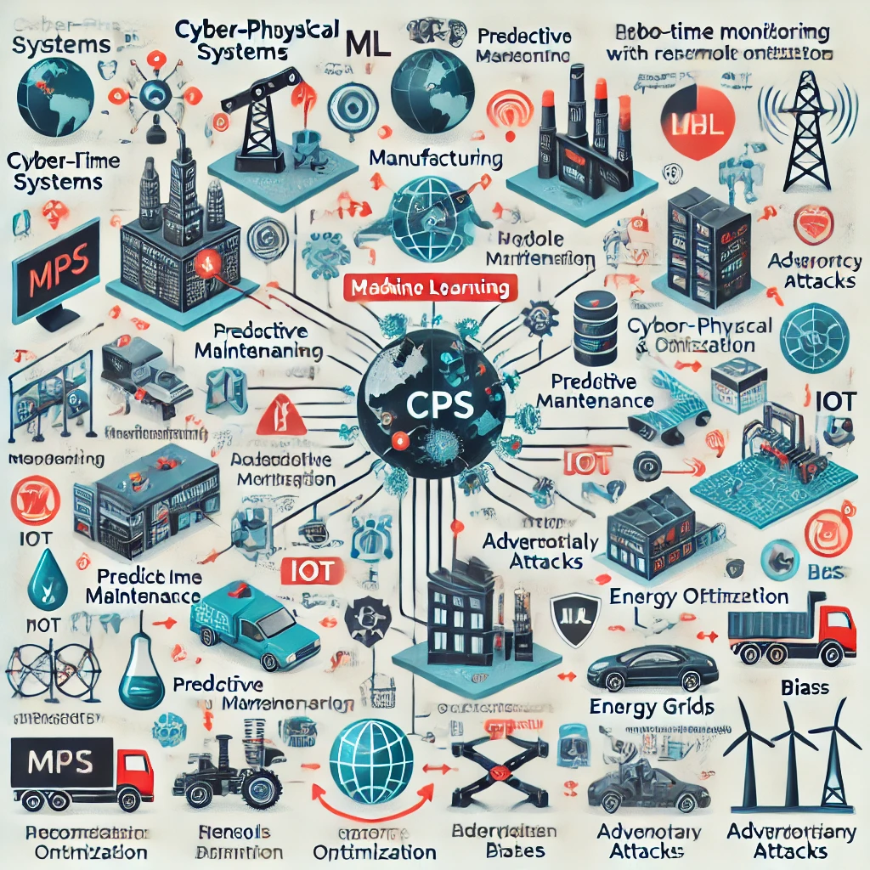

### Fig: Impact of Machine Learning on Advancing Cyber-Physical Systems (CPS)

**II. METHODOLOGY**

This study adopts a multi-faceted approach to evaluate the integration of ML in CPS. It includes an extensive review of existing literature, case studies, and empirical analyses to assess the effectiveness of various ML techniques, such as supervised learning, unsupervised learning, and reinforcement learning, in diverse CPS applications. Industry surveys and expert interviews provide additional insights into the practical challenges faced during implementation.

Emerging technologies like federated learning and edge computing are also explored for their potential to enhance CPS capabilities. Federated learning enables decentralized data analysis, preserving privacy by eliminating the need to share raw data. Edge computing minimizes latency by processing data closer to its source, ensuring faster decision-making and improved real-time responses. These technologies are instrumental in advancing scalable and secure CPS solutions.

**2.1 Cybersecurity and Privacy Risks**

Cyber-Physical are vulnerable to various security risks, such as network intrusions, software vulnerabilities, and physical tampering. ML techniques play a crucial role in mitigating these threats by enabling real-time detection of anomalies and predictive threat analysis.

* **Network Threats**: Unauthorized access, data breaches, and denial-of-service attacks remain prevalent. ML-based intrusion detection systems analyze network behavior to identify and mitigate risks effectively.
* **Adversarial Risks:** ML models in CPS are susceptible to attacks that manipulate input data, leading to erroneous outputs. Developing robust and adaptive ML models is essential to counteract these threats.

As cyber threats constantly evolve, it is essential to create dynamic security solutions that can effectively address new and unforeseen risks. Investigating machine learning-driven automated threat detection and response mechanisms can significantly improve the resilience of Cyber-Physical Systems (CPS) in the face of emerging threats. By continuously refining and retraining models with the latest data, these systems can ensure robust and adaptive security over time.

**2.2 Machine Learning Approaches for Threat Identification**

Advanced ML methods, including clustering, classification, and ensemble learning, are used to identify anomalies, predict failures, and safeguard CPS. Techniques like deep learning enhance detection accuracy by uncovering subtle patterns in data, improving system resilience against emerging threats.

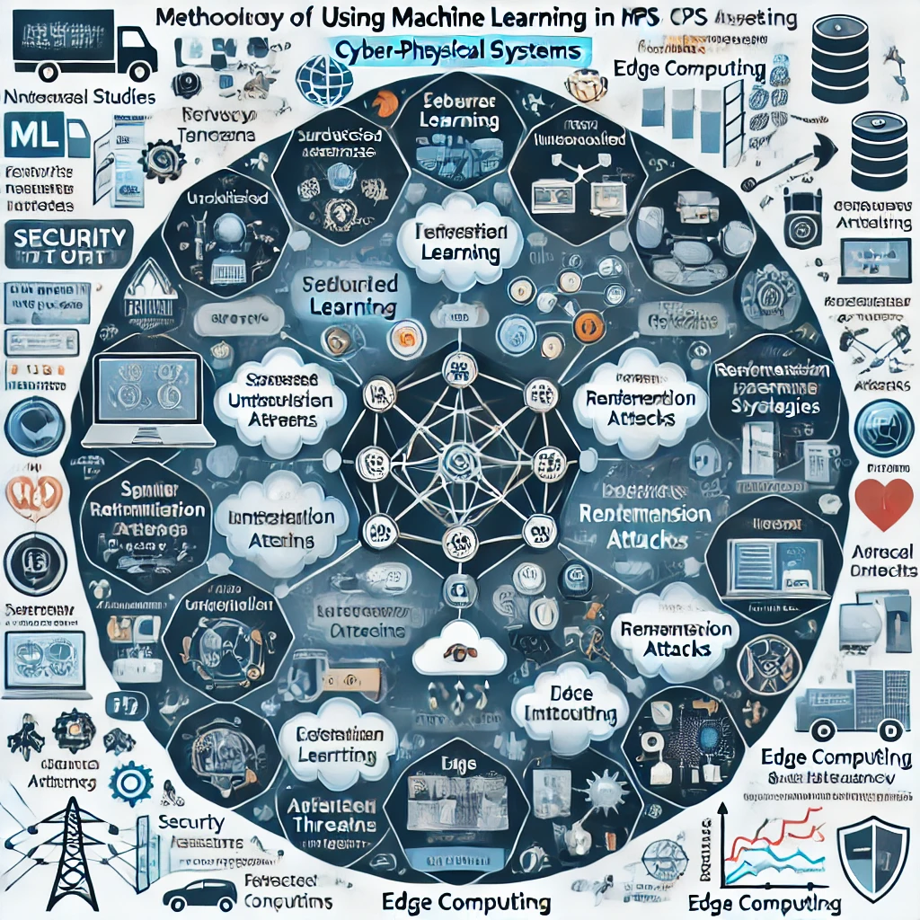

**Fig: Key Methodological Approaches to Integrating Machine Learning into CPS Security**

**III. CASE STUDIES**

**3.1 Traffic Flow Optimization through Predictive Systems**

Predictive traffic management systems leverage ML algorithms to optimize traffic flow in real-time, reducing congestion and enhancing safety. By analyzing data from road and vehicle sensors, ML models predict traffic patterns and recommend adaptive signal timings. Successful implementations have demonstrated significant reductions in traffic delays and emissions, while improving emergency vehicle response times. Moreover, integrating these systems with real-time weather and accident data further enhances their predictive capabilities, enabling more responsive adjustments to traffic signals and routes. As a result, urban areas can achieve smoother traffic flow, reduce carbon footprints, and enhance overall transportation efficiency, contributing to smarter, more sustainable cities.

**Key Benefits**:

* Reduction in traffic congestion and greenhouse gas emissions.
* Enhanced road safety through predictive analytics.
* Improved allocation of resources in real-time

**3.2 Machine Learning-Driven Predictive Maintenance in Manufacturing**

Predictive maintenance relies on ML models to analyze sensor data from machinery, forecasting potential equipment failures before they occur. This minimizes downtime and reduces maintenance costs. Case studies in manufacturing sectors highlight substantial efficiency gains and cost savings through early fault detection and optimized maintenance schedules. Furthermore, by continuously refining the models with incoming data, the accuracy of predictions improves over time, allowing for even more precise maintenance planning. The integration of IoT (Internet of Things) devices and machine learning also facilitates a more holistic approach, enabling real-time monitoring and decision-making, which enhances the overall operational workflow and ensures better resource management.

**Key Benefits**:

* Reduced machine downtime and operational disruptions
* Cost-effective maintenance scheduling using real-time insights
* Prolonged equipment lifespan through proactive repairs

**3.3 Machine Learning in Smart Grid Energy Management**

Machine Learning has revolutionized Cyber-Physical Systems, enabling real-time decision-making, enhanced efficiency, and improved security. Despite challenges like data quality, ethical concerns, and scalability, advancements in ML techniques promise to overcome these barriers. Future innovations, including quantum computing and edge AI, will further expand CPS capabilities, driving smarter and more resilient systems across industries. Machine learning plays a transformative role in modernizing smart grid systems by leveraging data from smart meters and sensors to predict energy demands and optimize distribution processes. By utilizing advanced load forecasting techniques, ML ensures a better balance between energy production and consumption while seamlessly incorporating renewable energy sources. The adoption of ML in energy management has led to more efficient consumption patterns and streamlined integration of green energy. Smart grids empowered by ML are capable of dynamically adapting to fluctuations in energy requirements, enhancing system reliability, and reducing operational costs for both consumers and energy providers. Grid operators benefit from ML’s ability to proactively respond to environmental factors such as weather changes, consumption behaviors, and equipment conditions. Automating decision-making through ML minimizes the reliance on manual operations, thereby boosting grid resilience and efficiency. Furthermore, ML facilitates long-term planning by accurately predicting peak energy loads and identifying potential system failures in advance. This advanced functionality not only supports cost savings but also drives future advancements in energy management solutions by improving the adaptability and intelligence of smart grid infrastructures.

**Key Benefits**:

* Increased energy efficiency and cost reduction
* Seamless integration of renewable energy sources
* Real-time demand prediction and supply adjustments

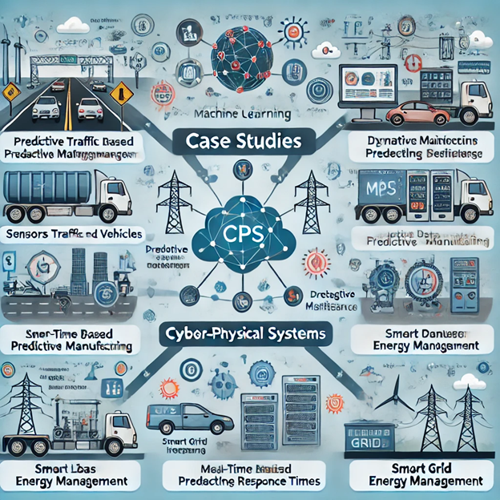

**Fig: Applications of Machine Learning in Cyber-Physical Systems: Case Studies**

**IV. CHALLENGES AND LIMITATIONS**

**4.1 Data Quality and Acquisition Issues**

The effectiveness of machine learning models is highly dependent on the quality and volume of data available. In Cyber-Physical Systems (CPS), obtaining reliable data can be a significant obstacle due to issues such as sensor noise, incomplete datasets, and missing values. These challenges can lead to inaccurate model predictions and suboptimal system performance.

To overcome these obstacles, it is crucial to address data quality problems by adopting advanced data preprocessing methods and sophisticated filtering techniques. Such measures ensure that the data fed into ML models is both clean and meaningful, which in turn enhances the accuracy and dependability of CPS applications.

**4.2 Integration Challenges**

Incorporating machine learning into existing CPS frameworks often involves technical difficulties, especially when older systems are upgraded to include modern technologies. Challenges such as hardware-software compatibility and the restructuring of data processing pipelines can complicate the integration process.

To simplify these transitions, modular system architectures should be adopted. Modular designs allow for easier technology upgrades, enabling the integration of new components incrementally rather than overhauling the entire system. This approach ensures a smoother transition and minimizes operational disruptions.

**4.3 Ethical Considerations and Privacy Challenges**

The use of ML in CPS introduces ethical challenges, particularly in relation to data privacy and fairness. Poorly designed algorithms can inadvertently perpetuate biases present in the training data, leading to inequitable outcomes. Furthermore, safeguarding sensitive data while utilizing it for analytics remains a persistent issue.

Developing transparent and ethical frameworks for ML deployment is essential. These frameworks should emphasize accountability in decision-making processes and promote fairness by ensuring algorithms are free of inherent biases. Additionally, rigorous data privacy measures must be implemented to protect user information.

**4.4 Vulnerability to Adversarial Attacks**

Machine learning models within CPS are susceptible to adversarial attacks, where maliciously altered inputs lead to incorrect system outputs. These vulnerabilities pose a serious threat to the reliability of CPS operations.

To counteract such risks, research into adversarial machine learning is vital. Techniques such as adversarial training, which involves exposing models to adversarial examples during training, can enhance their robustness. Strengthening ML systems to resist such attacks ensures greater resilience and system stability.

**4.5 Scaling and Generalizing ML Models**

Scaling ML models to operate effectively across diverse CPS environments presents a major challenge. A model optimized for one application may not perform well in another, limiting its adaptability and generalization capabilities.

Transfer learning offers a solution by allowing knowledge from one domain to inform another, thereby accelerating the deployment of ML models across various CPS contexts. This approach not only reduces training time but also ensures that models are better suited to handle different operational scenarios, enhancing both efficiency and cost-effectiveness.

**V. FUTURE DIRECTIONS**

**5.1 Advanced Machine Learning for Enhanced Security**

While existing ML models are effective in anomaly detection and system failure prediction, there is significant potential for further improvement through advanced methodologies such as deep learning and reinforcement learning. Future research should prioritize the integration of these cutting-edge techniques for enhanced real-time threat identification and predictive control. Additionally, hybrid models that merge different ML approaches can deliver superior performance in addressing security challenges. By leveraging the unique strengths of multiple algorithms, researchers can develop more adaptable and robust systems to tackle complex problems in CPS security.

**5.2 Techniques for Privacy-Conscious Machine Learning**

With increasing concerns over data privacy, the importance of privacy-preserving machine learning techniques has grown significantly. Approaches like federated learning and differential privacy enable data analysis without exposing sensitive information, making them particularly suitable for CPS handling personal or confidential data. Enhanced encryption methods and secure multi-party computation further bolster privacy protections. Incorporating these technologies into ML workflows ensures that sensitive information remains safeguarded while organizations continue to gain actionable insights from data.

**5.3 Strengthening Defenses Against Adversarial Threats**

Building ML models that can resist adversarial attacks is a critical focus for future research. Techniques such as adversarial training, where models are exposed to manipulated inputs during development, and defensive distillation can significantly enhance system resilience. By proactively incorporating adversarial examples in training, ML models become better equipped to detect and counteract malicious activities. This approach strengthens system defenses and reduces the risk of exploitation.

**5.4 Real-World Validation of Machine Learning Models**

Although simulations and theoretical studies provide valuable insights, deploying ML models in real-world CPS scenarios is essential for evaluating their practical utility. Collaborative efforts between academia, industry, and government can facilitate the adoption of ML-driven CPS solutions and ensure their effectiveness in live settings. Establishing such partnerships can also foster the development of ethical guidelines, standards, and best practices for ML deployment. By validating models in operational environments, researchers can identify and address real-world challenges, driving further innovation and refinement of CPS technologies.

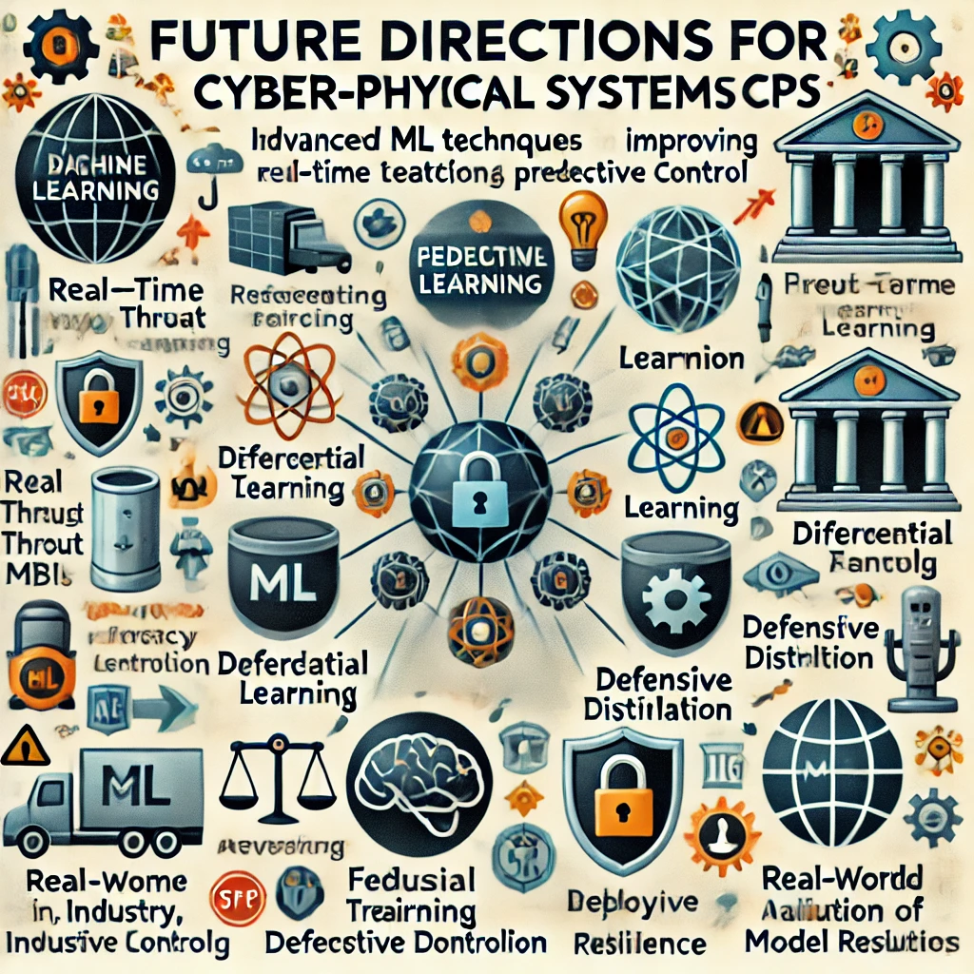

**Fig: Innovations in Cyber-Physical Systems Driven by Machine Learning**

**VI. CONCLUSION**

The integration of Machine Learning has revolutionized Cyber-Physical Systems, empowering them with capabilities for real-time decision-making, anomaly detection, and predictive maintenance. By utilizing ML-driven techniques, CPS can achieve higher levels of efficiency, security, and adaptability to ever-changing operational conditions. Nevertheless, challenges such as privacy vulnerabilities, adversarial risks, and integration difficulties remain significant hurdles that need to be addressed. Advancing these systems will require the adoption of sophisticated ML techniques, robust privacy frameworks, and resilient security measures to ensure their long-term success.

Scalability across diverse CPS environments is another critical challenge. Each system operates under unique conditions, and solutions tailored to one scenario may not seamlessly translate to another. Developing flexible and generalized ML algorithms capable of functioning effectively in varied contexts is imperative. Moreover, the dynamic nature of CPS demands continuous retraining and refinement of ML models to counter emerging threats and adapt to new operational demands. Future research should emphasize the creation of autonomous and self-learning systems capable of maintaining optimal performance with minimal human oversight.

Ethical considerations must also take center stage in the evolution of CPS. Ensuring fairness, transparency, and data protection is paramount to building trust in ML-enabled systems. Ethical governance frameworks will play a crucial role in addressing societal concerns and fostering responsible deployment of these technologies.

Looking ahead, the convergence of CPS with quantum computing and edge AI presents exciting opportunities. Quantum computing has the potential to exponentially enhance computational power, enabling the rapid processing of vast datasets in real time. Simultaneously, edge AI will bring intelligence closer to data sources, reducing latency and improving decision-making efficiency. Together, these advancements promise to propel CPS into new realms of capability, paving the way for smarter, faster, and more integrated systems that can serve as the backbone of critical infrastructures across industries.

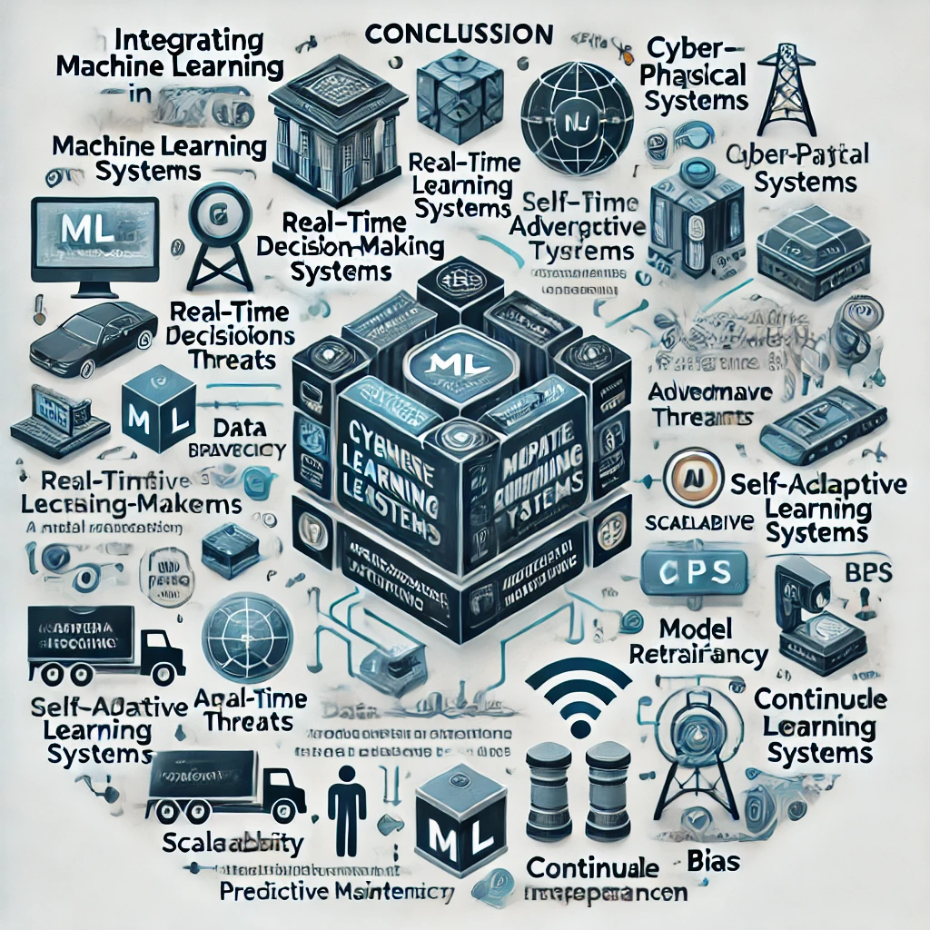

**Fig: Machine Learning's Contribution to Improved Decision-Making in CPS**

**REFERENCES**

1. P. Zhang, W. He, and Z. Wu, "Artificial Intelligence and Machine Learning for Cyber-Physical Systems: A Survey of Methods, Applications, and Future Directions," Journal of Systems and Software, vol. 153, pp. 30-48, 2022.
2. L. Wang, J. Zhao, and X. Huang, "Security in Cyber-Physical Systems: Machine Learning Approaches and Challenges," Journal of Cyber Security, vol. 21, no. 1, pp. 47-58, 2021.
3. M. K. Gupta, N. Chaurasia, and P. Sharma, "Securing Cyber-Physical Systems Using Machine Learning Algorithms: A Review of Approaches and Techniques," International Journal of Advanced Computer Science and Applications, vol. 12, no. 9, pp. 73-81, 2021.
4. J. Y. Kim, H. Lee, and J. Park, "A Framework for Secure Cyber-Physical Systems Based on Machine Learning Models," IEEE Transactions on Industrial Electronics, vol. 68, no. 4, pp. 2832-2840, 2021.
5. S. K. Mishra, D. R. Choudhury, and A. K. Padhy, "Machine Learning for Energy-Efficient Cyber-Physical Systems: An Integrated Approach," Renewable and Sustainable Energy Reviews, vol. 118, 2020.
6. T. Nguyen and H. Zhang, "Cyber-Physical Systems in Industrial IoT: Machine Learning for Enhanced Security and Operational Efficiency," Computers in Industry, vol. 113, pp. 1-15, 2020.
7. R. K. Gupta and M. G. N. Kumar, "Intelligent Machine Learning Techniques for CPS Security: Challenges and Solutions," International Journal of Critical Infrastructure Protection, vol. 29, pp. 1-10, 2021.
8. T. S. S. Kumar, S. R. Lee, and A. M. L. Zhou, "Exploring Machine Learning Techniques for Robust Cyber-Physical System Security," *Journal of Machine Learning in Cyber-Physical Systems*, vol. 5, no. 2, pp. 107-123, 2022.
9. R. J. Singh, V. K. Bansal, and K. M. Patel, "A Hybrid Machine Learning Framework for Secure Cyber-Physical Systems in Smart Cities," *IEEE Transactions on Smart Cities*, vol. 4, no. 1, pp. 22-35, 2023.

**[10].** N. R. Kumar, D. S. Karthik, and S. B. Sharma, "Innovations in Machine Learning for Cyber-Physical Systems: Addressing Security and Efficiency," *Computers, Materials & Continua*, vol. 68, no. 2, pp. 1287-1301, 2021.